Silistra 1806
1 Insanustu Pasha
Upon French advise, and encouraged by the recent Russian defeats in Central Europe, in 1806 Sultan Selim III formally broke the 1792 treaty of Jassy and launched a massive offensive across the Danube against Russian occupied Bucharest. Thus starting the sixth Russo-Turkish war. Unfortunately, the Ottoman advance bogged down due to logistic problems and squabbling commanders, and was easily repulsed. Russia felt that it should exploit this easy success, but in view of the dire situation in Central Europe could only spare limited resources for the Turkish front. Help was solicited from the Austrian and Prussian allies, and the three parties agreed to free up two corps each for a secret expedition to secure a bridgehead at Silistra. This would secure a foothold at the Danube for future incursions into the Ottoman empire after the French menace had been dealt with.
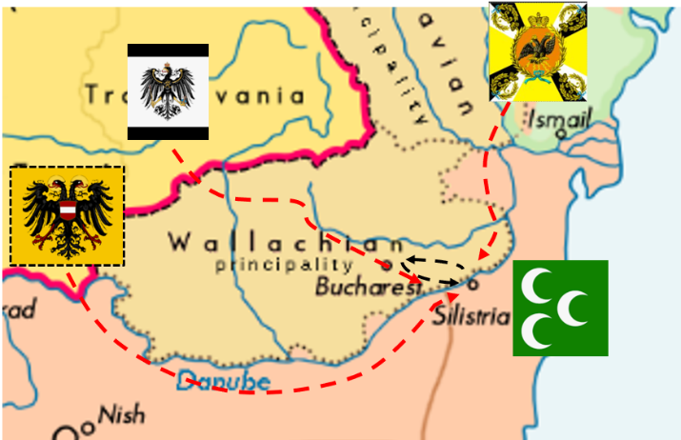
Co-ordination between the approaching armies was a major concern. By progressing slowly the three columns managed to arrive at Silistra simultaneously. But it had given the Ottomans the opportunity to gather strength. And a brilliant new commander: Insanüstü Pasha. Intuitive, legendary and a master of staff work. Having come to the scene just one day before the arrival of the allies, he will now have to organize the defenses. The Sultan’s troops are camped around Silistra while the provincial militia are camped in the countryside. The cavalry are still grazing their horses on the lush hills to the south.
Below the commanders of the allied armies. From left to right: Franz Freiherr Von Werneck, Count Ferdinand von Waldstein, Baron Vasili Buggerov.
